연구 윤리 과제 3주차

1. 전이 학습을 적용하여 영상 분류 하기

* 여러가지 모델을 전이 학습을 시도 하였으나 코랩의 에러와 학습 시간의 과대로

학습 실패

* DensNet210 모델로 전이 학습을 실행 코랩 7 epochs 4시간 정도 걸림
* 시간이 오래 걸려도 PC로 옮겨서 여러 모델를 비교 후 정확도 비교

1. 손실 함수 그래프를 그려 학습률이 어떻게 되는지 알아 보기

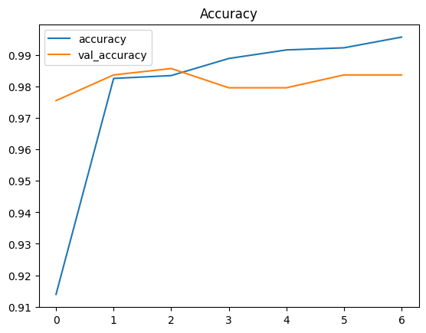

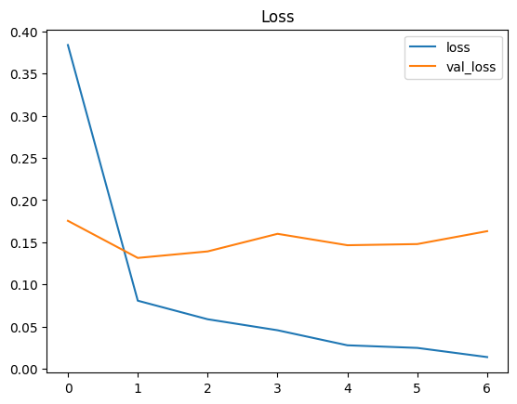

Found 4415 validated image filenames belonging to 19 classes.

Found 490 validated image filenames belonging to 19 classes.

Found 545 validated image filenames belonging to 19 classes.

Epoch 1/7

138/138 [==============================] - 1683s 12s/step - loss: 0.0138 - accuracy: 0.9957 - val_loss: 0.1631 - val_accuracy: 0.9837

**Accuracy on the test set: 97.98%**

precision recall f1-score support

AGear 1.00 1.00 1.00 40

Abearing 0.97 0.95 0.96 41

Amotor 0.94 1.00 0.97 30

Aoil 1.00 1.00 1.00 54

Ashaft 0.98 0.94 0.96 54

Gear 0.96 1.00 0.98 23

Gear casing 1.00 1.00 1.00 28

Motor casing 1.00 1.00 1.00 29

Motor_up 1.00 1.00 1.00 21

bearing_gear 1.00 0.97 0.99 34

bearing_motor 1.00 1.00 1.00 32

bypass 1.00 1.00 1.00 9

flange 0.98 1.00 0.99 49

lipseal 0.88 1.00 0.94 22

other 1.00 0.67 0.80 3

outlet 0.93 1.00 0.96 13

stator 1.00 0.88 0.93 32

stator_inlet 1.00 1.00 1.00 19

stator_shaft 0.92 1.00 0.96 12

accuracy 0.98 545

macro avg 0.98 0.97 0.97 545

weighted avg 0.98 0.98 0.98 545

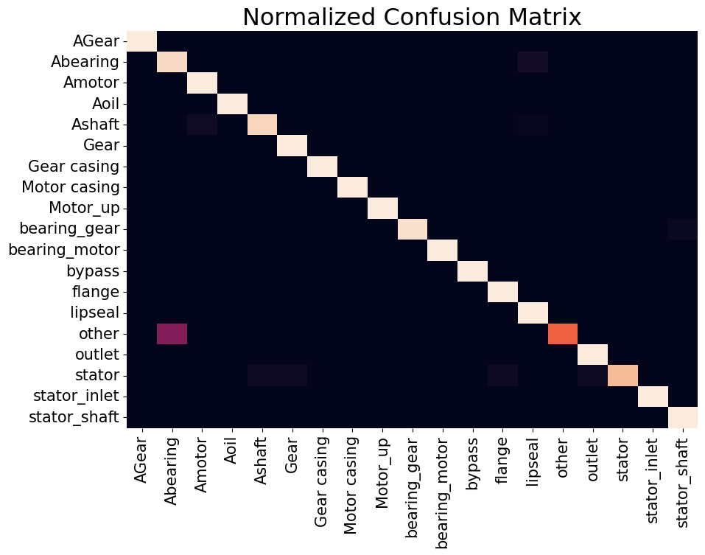

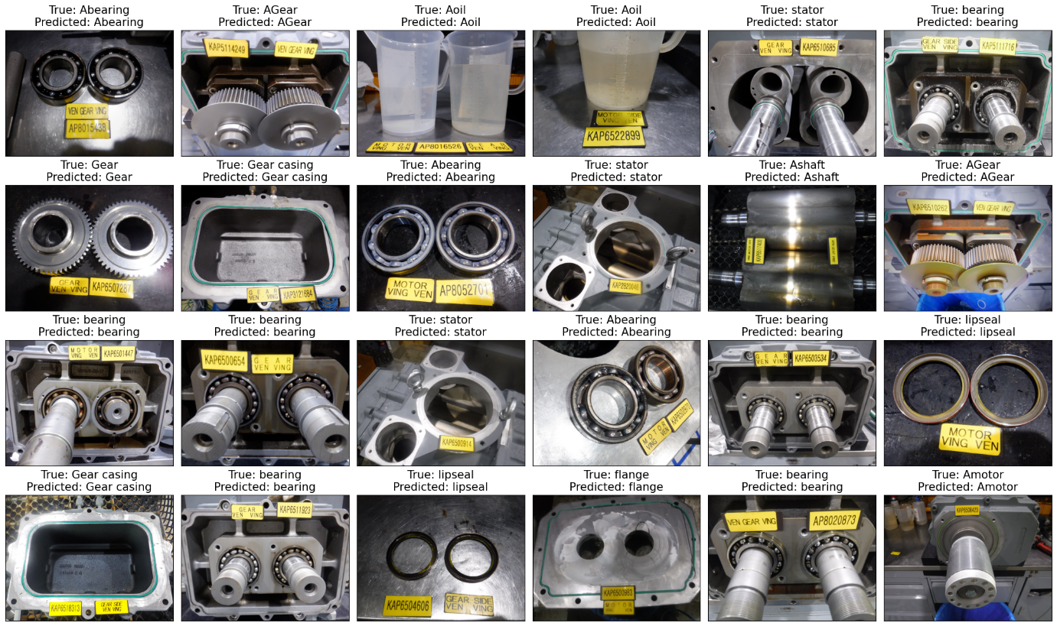

1. CNN 모델이 영상 어는 곳을 지켜 보고 있는지 알아보기

* 못했습니다….

|  |  |  |  |  |  |
| --- | --- | --- | --- | --- | --- |
| Optimizer | 11 | 12 | 13 | 14 | 15 |
| RSMprop | 94.60% | 96.28% | 94.84% | 93.05% | 93.36% |
| Nadam | 92.90% | 94.48% | 93.84% | 91.95% | 92.16% |
| Adam | 96.38% | 96.78% | 96.12% | 97.38% | 97.73% |
| AdamW | 95.10% | 93.22% | 95.14% | 92.63% | 96.04% |
| AdamX | 93.90% | 95.68% | 95.64% | 93.55% | 93.46% |
|  | 16 | 17 | 18 | 19 | 20 |
| RSMprop | 92.21% | 95.61% | 95.62% | 93.56% | 93.90% |
| Nadam | 91.11% | 94.51% | 93.92% | 92.16% | 92.20% |
| Adam | 97.09% | 97.10% | 96.50% | 97.63% | 97.23% |
| AdamW | 93.29% | 93.49% | 94.38% | 93.96% | 95.96% |
| AdamX | 93.01% | 96.31% | 95.72% | 93.46% | 94.10% |

|  |  |  |  |  |  |
| --- | --- | --- | --- | --- | --- |
| Optimizer | 11 | 12 | 13 | 14 | 15 |
| RSMprop | 94.60% | 96.28% | 94.84% | 93.05% | 93.36% |
| Nadam | 92.90% | 94.48% | 93.84% | 91.95% | 92.16% |
| Adam | 96.38% | 96.78% | 96.12% | 97.38% | 97.73% |
| AdamW | 95.10% | 93.22% | 95.14% | 92.63% | 96.04% |
| AdamX | 93.90% | 95.68% | 95.64% | 93.55% | 93.46% |
|  | 16 | 17 | 18 | 19 | 20 |
| RSMprop | 92.21% | 95.61% | 95.62% | 93.56% | 93.90% |
| Nadam | 91.11% | 94.51% | 93.92% | 92.16% | 92.20% |
| Adam | 97.09% | 97.10% | 96.50% | 97.63% | 97.23% |
| AdamW | 93.29% | 93.49% | 94.38% | 93.96% | 95.96% |
| AdamX | 93.01% | 96.31% | 95.72% | 93.46% | 94.10% |

|  |  |  |  |
| --- | --- | --- | --- |
| measure | precision | recall | f1-score |
| accuracy | - | - | 0.98 |
| macro avg | 0.98 | 0.97 | 0.97 |
| weighted avg | 0.98 | 0.98 | 0.98 |

|  |  |  |  |
| --- | --- | --- | --- |
| measure | precision | recall | f1-score |
| AGear | 1 | 1 | 1 |
| Abearing | 0.97 | 0.95 | 0.96 |
| Amotor | 0.94 | 1 | 0.97 |
| Aoil | 1 | 1 | 1 |
| Ashaft | 0.98 | 0.94 | 0.96 |
| Gear | 0.96 | 1 | 0.98 |
| Gear casing | 1 | 1 | 1 |
| Motor casing | 1 | 1 | 1 |
| Motor_up | 1 | 1 | 1 |
| bearing_gear | 1 | 0.97 | 0.99 |
| bearing_motor | 1 | 1 | 1 |
| bypass | 1 | 1 | 1 |
| flange | 0.98 | 1 | 0.99 |
| lipseal | 0.88 | 1 | 0.94 |
| other | 1 | 0.67 | 0.8 |
| outlet | 0.93 | 1 | 0.96 |
| stator | 1 | 0.88 | 0.93 |
| stator_inlet | 1 | 1 | 1 |
| stator_shaft | 0.92 | 1 | 0.96 |
| measure | precision | recall | f1-score |
| accuracy | - | - | 0.98 |
| macro avg | 0.98 | 0.97 | 0.97 |
| weighted avg | 0.98 | 0.98 | 0.98 |
| measure | precision | recall | f1-score |
| stator | 1 | 0.88 | 0.93 |
| lipseal | 0.88 | 1 | 0.94 |
| other | 1 | 0.67 | 0.8 |
| outlet | 0.93 | 1 | 0.96 |

|  |  |  |  |
| --- | --- | --- | --- |
| measure | precision | recall | f1-score |
| stator | 1 | 0.88 | 0.93 |
| lipseal | 0.88 | 1 | 0.94 |
| other | 1 | 0.67 | 0.8 |
| outlet | 0.93 | 1 | 0.96 |